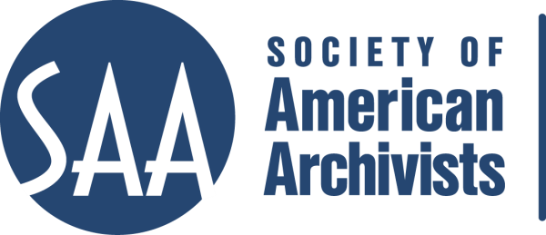
CE Workshop Evaluation Form
Arrangement and Description Track

Workshop Evaluation Form:

Title
Reviewer:
Directions:
- Quantitative: Each item below begins with a bolded statement. Score each with a 1-5 ranking to indicate your assessment of the veracity of that statement based on your review of workshop overviews/agendas, evaluations, and other materials.
- Qualitative: In the comments section for each item below, please respond to the additional questions posed and any related issues that this workshop raises for you.
- Provide any additional assessments or comments not relevant to one of the specific, numbered areas in the space provided following the table.

Please place an “x” in the appropriate column, use 1=low, undesirable, to 5=high, excellent. |  |  | 1 | 2 | 3 | 4 | 5
1. Does the content appeal to its specified audience? Does it indicate specific categories of archivists and/or levels of expertise to assist potential participants in determining the workshop's relevance for them?
Comments:
2. To what extent does the subject matter reflect current archival practices and theory commonly accepted in the profession?
Comments:
3.. How relevant/appropriate are the teaching and delivery methodologies (lecture, video, PowerPoint, exercises, film, audiotape, discussion, simulation, case study, opportunities for in-course feedback, etc.) to the articulated goals and objectives, and to the content?"
Comments:
4. How workable is the time line or agenda for the course? Is there sufficient detail to indicate how the workshop will evolve? Does it allow sufficient time for active engagement between course participants and the instructor(s)?
Comments:
5. To what degree does the list of assigned readings support the content of the proposal?
Comments:
6. Does the presentation support the Learning Outcomes in the descriptions?
Comments:
 | A&D Track Considerations
 | 1.Does this content bridge, enhance, and/or build on other workshops (If so, please name)
 | 2.Does this build on other workshops not on the list?
 | 3 Should this be part of the A&D Track?
 | 4.Where would this workshop fall in the sequence of an A&D track?
 | Why?
 | 5. What tier does this workshop fall in? (See attached tiers)
 | 6. Target Audience | Attached list of tracks can be used to indicate appropriate level of experience and job function
 | 7. Is the suggested prior “experience/knowledge” appropriate? | Knowledge that participants will need to gain the most from the workshop; include any workshop (from the list of suggested A&D workshops) that you suggest be taken before attending this course.  For descriptions go to http://www2.archivists.org/prof-education/course-catalog
 | 8. Learning Outcomes:  Are they appropriate and/or relevant? | List of specific, measurable, and actionable outcomes that each person should be able to do (e.g. discuss, explain, evaluate, design) by the end of the course.
9. What should they be?
Please list learning outcomes.
 | 10. Can you make suggestions for competencies this workshop would fulfill?
 | 11. Would parts of the content lend themselves to a different format? | Check one: Webinar: - 30 minute - 90minute In person: - 1/2 day - 1 day - 2 day
 | 12. Which parts?
 | 13. Does it lend itself to repurposing as an audio CD?
 | Which parts?

Other comments:

